# ZonMw research highlights food security vulnerabilities in Curacao, Aruba and Sint Maarten, exacerbated by COVID-19 pandemic

In a recent study conducted by ZonMw, the spotlight has been cast on the critical issue of food security in the Dutch Caribbean territories of Curaçao, Aruba, and Sint Maarten. The research brings to light the vulnerabilities in these island communities, which have been further intensified by the global health crisis brought on by the COVID-19 pandemic. According to ZonMw project lead X.x: “Food Security and Livelihood Protection surveys conducted by the World Food Programme spanning the entire Caribbean, has provided valuable insights into the state of food security in the midst of the pandemic. This article delves into the data made available for the islands Curaçao, Aruba, and Sint Maarten following the COVID pandemic.

This survey is interesting because it provides a very good comparable data set for the CAS islands as well as the Caribbean region as a whole, which is very unique for the region.

**Chart X: Food Security and Livelihood Protection survey sample June 2020**

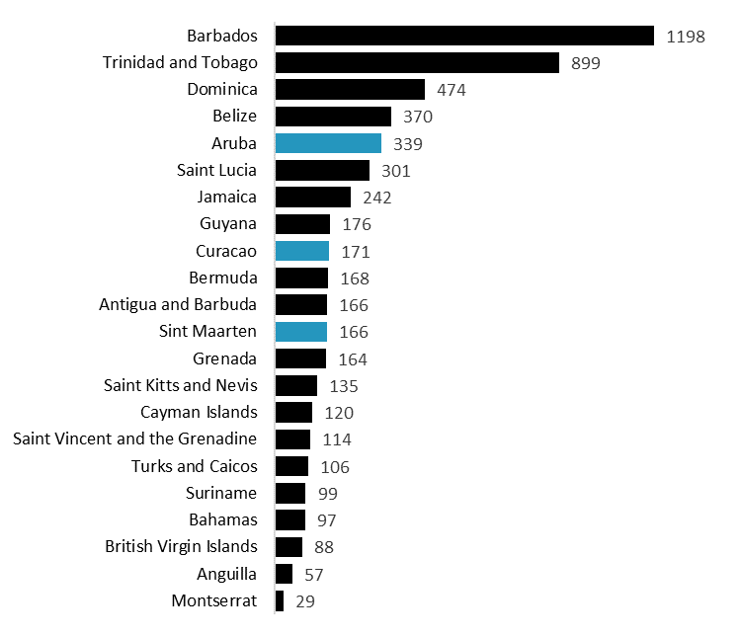

*Source: World Food Programme (2020)*

## The case for Curaçao, Aruba, and Sint Maarten

Curaçao, Aruba, and Sint Maarten, though known for their stunning landscapes and vibrant cultures, face significant challenges in ensuring food security for their populations. The ZonMw research delves into the intricate web of factors influencing these vulnerabilities, ranging from economic conditions to environmental concerns.

**Chart 1: GDP per capita (in USD)**

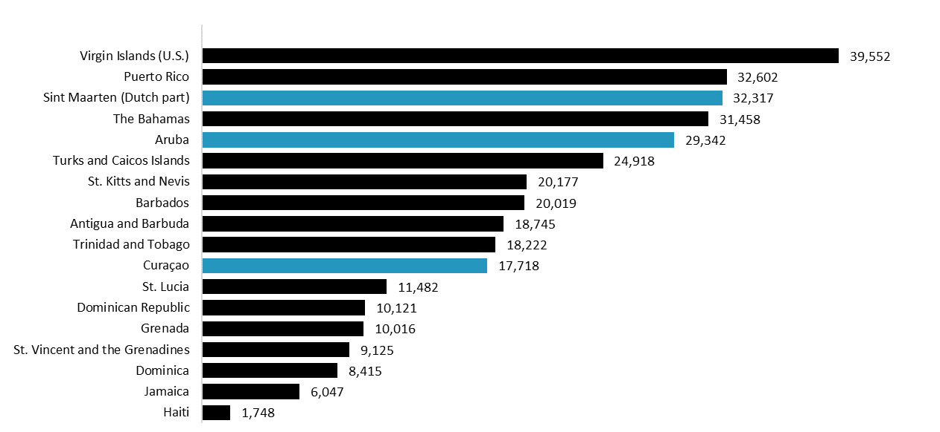

*Source: World Bank Group (2023)*

Particularly Sint Maarten and Aruba stand out as having a relatively high GDP per capita relative to Caribbean peers. Yet despite this, the CAS islands are heavily dependent on tourism and have relatively limited local food production.

**Chart 2: Tourism and Food production in the Caribbean**

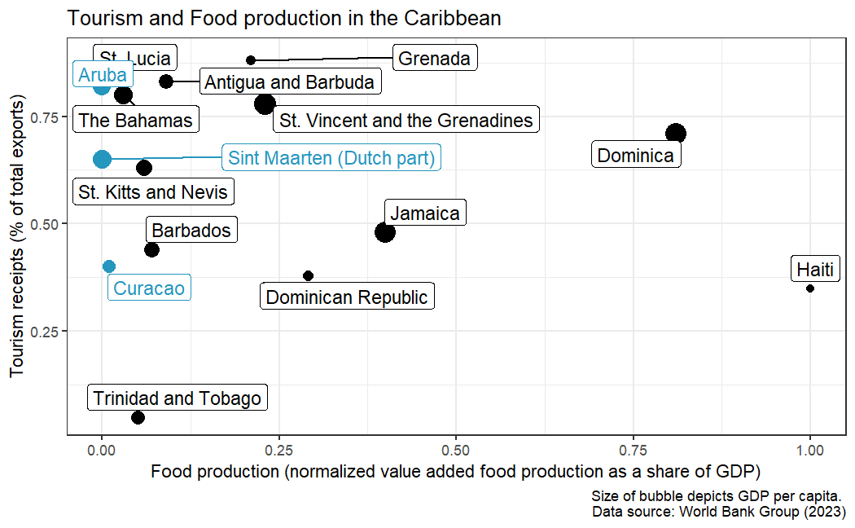

*Source: World Bank Group (2023)*

## Markets

**Chart X: Access to market: In the past 7 days, was there a time when your household could not access the markets?**

*Source: WFP (2023)*

## Food security

## Livelihoods

## Wider impacts

## Impact of the COVID-19 Pandemic

The global pandemic has acted as a magnifying glass, exposing and exacerbating existing issues in the realms of health, economy, and, notably, food security. Lockdowns, travel restrictions, and disruptions to the supply chain have made access to food even more challenging for vulnerable communities in these Caribbean territories.

## Key Findings

Economic Disparities: The research highlights the economic disparities that contribute to unequal access to food resources. Lower-income households, already grappling with financial constraints, find it increasingly difficult to secure a stable food supply.

Environmental Challenges: Curaçao, Aruba, and Sint Maarten face unique environmental challenges, including climate change impacts and limited arable land. These factors play a role in food production challenges and availability.

Community Resilience: Despite the challenges, the research also sheds light on the resilience of local communities. Grassroots initiatives, community gardens, and collaborations have emerged as crucial components in the fight against food insecurity.

1. Access to Nutritious Food: The survey highlights a concerning decrease in the accessibility of nutritious food across all three islands, indicating an immediate need for targeted interventions.

2. Economic Impacts: The economic fallout from the pandemic has disproportionately affected vulnerable populations, emphasizing the importance of socio-economic support measures.

3. Community Resilience: Despite the challenges, the survey identifies pockets of community resilience, suggesting that building on local strengths can be a key element in developing effective solutions.

## Call to Action

The findings of the ZonMw research underscore the urgent need for coordinated efforts at local, national, and international levels. Addressing the root causes of food security vulnerabilities requires a multifaceted approach, encompassing economic policies, environmental conservation efforts, and community-based initiatives.

ZonMw's research has been instrumental in shedding light on these vulnerabilities, providing a foundation for informed decision-making. By focusing on the specific challenges faced by each island, tailored strategies can be developed to address the unique needs of Curaçao, Aruba, and Sint Maarten.

As we navigate the complex landscape of a post-pandemic world, addressing food security vulnerabilities in Curaçao, Aruba, and Sint Maarten must be a priority. ZonMw's research serves as a catalyst for informed action, guiding policymakers and stakeholders towards sustainable solutions that will not only alleviate the immediate crisis but also contribute to long-term resilience in these Caribbean islands.

In the spirit of international collaboration, it is crucial that the findings of this survey are used to inform targeted interventions, foster community engagement, and build a foundation for a more secure and resilient future for all. The road ahead may be challenging, but with strategic and compassionate efforts, we can overcome the obstacles and create positive change for the communities of Curaçao, Aruba, and Sint Maarten.

Let us unite in our commitment to ensuring food security for all, recognizing that the well-being of one island is intricately connected to the prosperity of the entire region.

As we navigate the complexities revealed by this research, it is imperative for stakeholders, policymakers, and community leaders to come together. Collaborative solutions, investment in sustainable practices, and the empowerment of local communities will play pivotal roles in building a more resilient and food-secure future for Curaçao, Aruba, and Sint Maarten.

In conclusion, the ZonMw research serves as a clarion call, urging us to prioritize the issue of food security in these Caribbean territories. By acknowledging the challenges and working collectively towards solutions, we can pave the way for a more sustainable and secure future for all.

Stay tuned for more updates as we explore potential strategies and initiatives to address these critical issues.

#FoodSecurity #ZonMwResearch #CaribbeanResilience #COVID19Impact